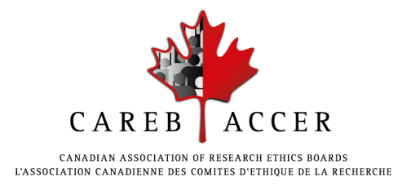

Circle of Experts Member Application Form

The CAREB-ACCER Circle of Experts has been created to provide a directory of experts to assist CAREB-ACCER in the development and delivery of educational opportunities including conference sessions, workshops, e-learning modules and webinars. Individuals with significant expertise in research ethics and related fields and who have experience in content writing or teaching adult learners are asked to apply to join the CAREB-ACCER Circle of Experts.

Please complete this application form and submit it along with a written expression of interest and your most recent resume or Curriculum Vitae to Delilah Ofosu-Barko, CAREB-ACCER VP Professional Development and Circle of Experts Selection Sub-Committee Chair at delilah.ofosu-barko@trilliumhealthpartners.ca.

Please note that you may be asked for references.

Title (Mr/Ms/Dr):

Full Name:

Degree(s):

Affiliation(s):

Contact information:
email:
phone:

Location:
Province:
City:
Country:

Professional roles:

Field/specialty:

Sub-specialty:

Language(s) Spoken (select all that apply): English French
Language(s) Written (select all that apply): English French

Short biography (< 100 words):

CAREB programs you would be interested in contributing to:
conferences
workshops
webinars
online module content
other (please specify):

